3. Develop a Java program to create an abstract class EnergySource with members Source ID, Source Name, and Energy Generated (in kWh). Include an abstract method calculateEfficiency(). Derive the classes SolarEnergy and WindEnergy from EnergySource and implement the method based on the following criteria: For SolarEnergy, efficiency is calculated as (Energy Generated / 5000) × 100. For WindEnergy, efficiency is calculated as (Energy Generated / 8000) × 100. Display source details and efficiency percentage. Demonstrate dynamic method dispatch using an EnergySource reference.
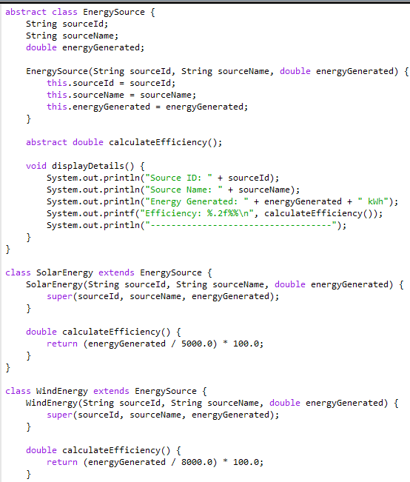

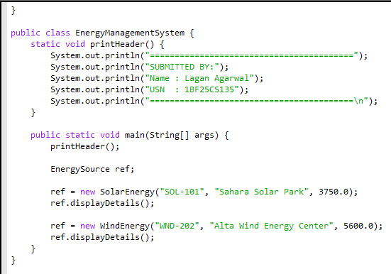

OUTPUT:


